

**HITEC UNIVERSITY TAXILA, CANTT**

**BSAI-(B)-1st Semester**

**LAB REPORT**

**AICT LAB**

**Fall 2024**

**Submitted To:**

Ms. AMNA SHAKEEL

**Submitted By:**

Sameer Ahmed (24-ai-013)

Hassan Minhas(24-ai-009)

Abdullah Tahir(24-ai-029)

**BS ARTIFICIAL INTELLIGENCE**

**PROGRAM DEPARTMENT OF COMPUTER SCIENCE __________UNIVERSITY, TAXILA____________**

**This file contains the code or the website:**

**Header Page code:**

First, we start with the basic structure of our HTML document. <Head Section>

The <head> section where we store metadata and styles.



• We set the character encoding to UTF-8 with <meta charset="UTF-8">, which allows us to use various characters properly.

• The <meta name="viewport"> tag helps our page be responsive, making sure it looks good on both desktops and mobile devices.

• The title <title>Services - Pet Shop</title> specifies what our webpage should be called in the browser tab.

• Finally, we’ve included <style> where we will write our CSS to style the page.

**Body and HTML Styles**

Next, we set styles for the body and HTML elements.



We choose Arial, sans-serif as our font, which gives a clean and modern look.

The line-height: 1.6; improves readability by spacing out the lines of text.

By setting background-color: #f4f4f4;, we give the page a light gray background.

min-height: 100%; ensures that our body takes up the entire height of the viewport.

**Container CSS Styles**

Now we’ll style our container.



We add margin-top: 120px; to create space for the fixed header so it doesn’t overlap with the content.

padding: 30px; adds space within the container to keep the content from touching the edges.

The Flexbox properties (display: flex; flex-direction: column; align-items: center;) help align our sections vertically and center them.

**Footer Section**

Now, we’ll create the footer.

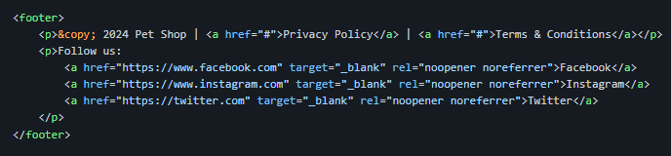

Our footer includes copyright information along with links to the Privacy Policy and Terms.

We also display social media links inviting users to connect with us on different platforms.

**THE MAIN PAGE**

We maintain the current styling while few strategic code lines to enhance the presentation and functionality of our Products page. This includes adding hover effects to the product cards, improving image responsiveness, and ensuring better accessibility.

**Section Elements:**

Each service is housed in its own section, enhancing clarity:

**Pricing Comments:**

In the Services page, we do not include any pricing in the descriptions:

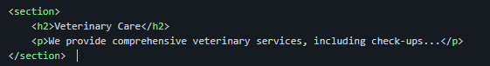



**Header and Footer:**

Pages share similar design elements like fixed headers for navigation:



**FOOTER/ CONTACT PAGE**

* **Document Structure and Metadata:**

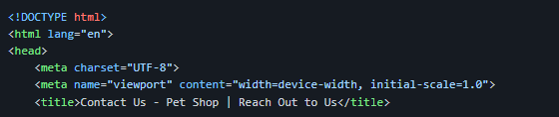

**Viewport Meta Tag:** This line ensures that the page is responsive and properly scaled on various devices, making the site more accessible on mobile devices.

**Title Element:** The title specifically reflects the page content (“Contact Us”), which is essential for SEO and user navigation.

* **Form Elements**

The contact form is unique to this page and includes several new elements:

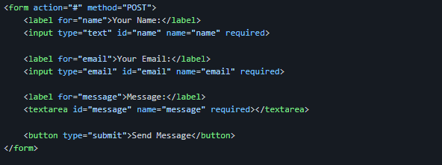

**Form Tag:** The <form> tag defines a form for user input with a specified action and method (POST). Here, the action is set to "#" for demonstration, which means the form data will not actually be submitted anywhere.

**Label Elements:** Use of <label> elements to make the form accessible. Each label is associated with an input via the for attribute, which connects it to the respective input fields.

**Text Input for Name:** <input type="text"> for user names.

**Email Input for Email:** <input type="email"> ensures that the email format is validated.

Textarea for Message: The <textarea> allows users to enter multi-line messages.

**Button Element:** The <button type="submit"> submits the form.

* **Footer Elements**

While similar to the footer in the other pages, we included the same structure, but emphasize the links: 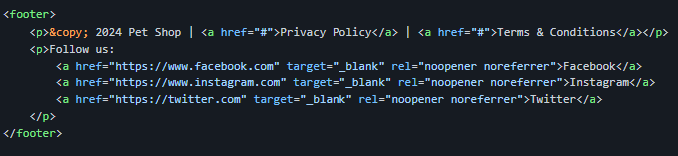

**Conclusion**

**The Pet Shop** website features three essential pages—Products, Services, and Contact Us—that work together to provide a cohesive and engaging user experience.

**Products Page**: Showcases pets for sale with visually appealing cards, clear descriptions, and responsive design, enhancing interactivity and ease of use.

**Contact Us Page**: Facilitates communication through a clear contact form and engaging content, encouraging visitors to get in touch, with attention to accessibility and responsiveness.

**Overall**, these pages create an intuitive online experience, promoting exploration and interaction while fostering a welcoming environment for pet lovers.